**Project #0**

**DC Motor Simulation in Simulink**

**Utku Erdem**

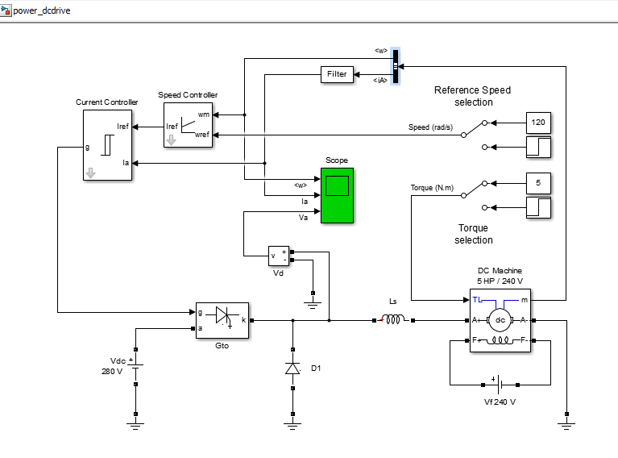

1. Information about the motor

Motor that is used in the project is 5HP/240V DC machine which is wound type field winding configuration. Its field windings are feeding from 240VDC. It has 0.5 Ohms armature resistance and 0.01 H armature inductance. Also field resistance and field inductance are 240 Ohms and 120H respectively. Field-armature mutual inductance value is 1.23 H. Total inertia of the rotor is 0.05 kg*m*m. Viscous friction related to the motor is 0.02 N*m*s. Also note that, initial speed of the rotor is given as 0.1 rad/s.

1. Information about the power source and control system

There are 2 types of power sources in this model. Field windings of the motor are fed by 240VDC. The voltage that is used to feed armature of the motor is given as 280VDC.

When we examine the control system of the given design, we can say that there is a feedback loop which takes measurements from the motor (current and angular velocity readings), and then compare them with the reference values. Reference value of the current is obtained by PI controller which takes two inputs which are simply w_ref and w_m. Of cource here w_ref is user defined. After that current the controller works as ON-OFF controller. When I_ref is greater than I_a by the amount of half of the hysteresis band (in this case it is equal to 2A), output of the comparator is equal to 1 otherwise it is 0. Output of the ON-OFF controller goes to gate of the GTO so that power which is supplied to the armature can be adjusted. This is how control loop works in this process.

1. Graphs showing acceleration curve from stationary to rated speed

When output torque is set to be 5N.m and reference speed is equal to 120 rad/sec, graphs can be seen in the below fig.1.

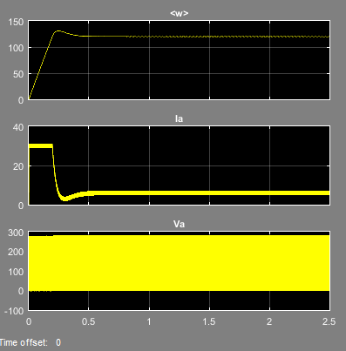

(Fig.1 Output graphs that are related to the acceleration of the machine)

Also in the Fig.2 a zoomed in version of the above figure can be seen. Here important point is voltage that is applied to the armature, as stated in the control loop explanation, is a square wave which has changing duty cycle with respect to the operation point. Also since within a short interval speed of the rotor can be assumed as constant, which leads to constant load for a short time, triangular like current waveform is expected.

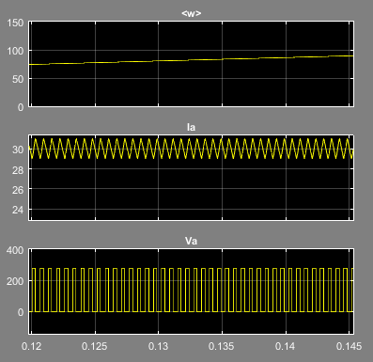

(Fig.2 zoomed in version of the initial acceleration graph)

1. Start-up current graphs

There are two switches to change torque and reference speed of the motor. Current graphs to each case will be presented below.

* w_ref=120rad/sec and Torque = 5 N.m

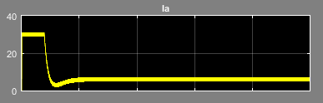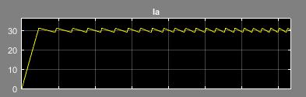

(Fig.3 Current graph related to above case) (Fig.4 Start-up current graphs)

* w_ref=120rad/sec and Torque = 5 N.m and =25 N.m after 1.2 seconds

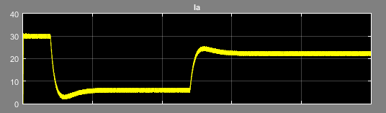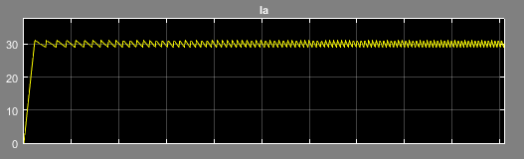

(Fig.5 Current graph related to above case) (Fig.6 Start-up current graphs)

* w_ref=120rad/sec and =160 after 0.4 seconds and Torque = 5 N.m

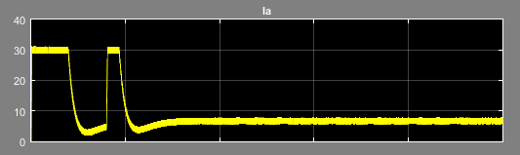 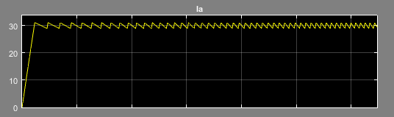

(Fig.7 Current graph related to above case) (Fig.8 Start-up current graphs)

* w_ref=120rad/sec and =160 after 0.4 seconds and Torque = 5 N.m and =25 N.m after 1.2 seconds

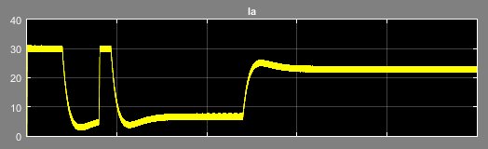 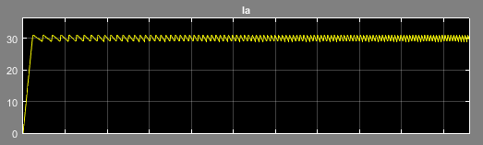

(Fig.9 Current graph related to above case) (Fig.10 Start-up current graphs)

1. Produced torque during startup

In order to obtain torque graph we have to scale I_a graph since we know that torque is multiple of armature current. In steady state armature current has 6 A average value and motor has 5 N.m. So when we multiplied current by 5/6 torque graph should be obtained.

In the below Fig.11 it can be seen that torque graph looks similar to current graph.

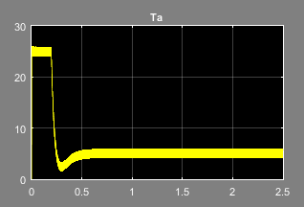

(Fig.11 Torque Graph)

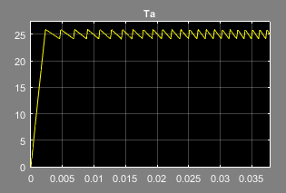

(Fig.12 Startup Torque graph)

Startup torque graph can be seen in above fig.12.

1. Bibliography

I simply used the same model which is provided by our instructor at the given link below;

https://www.mathworks.com/help/physmod/sps/examples/chopper-fed-dc-motor-drive-continuous.html

Also typing “power_dcdrive” to the command window will open same model.